**VPC Task- 02:**

1. **Create one VPC,with 1 one public subnet and 1 private subnet.**

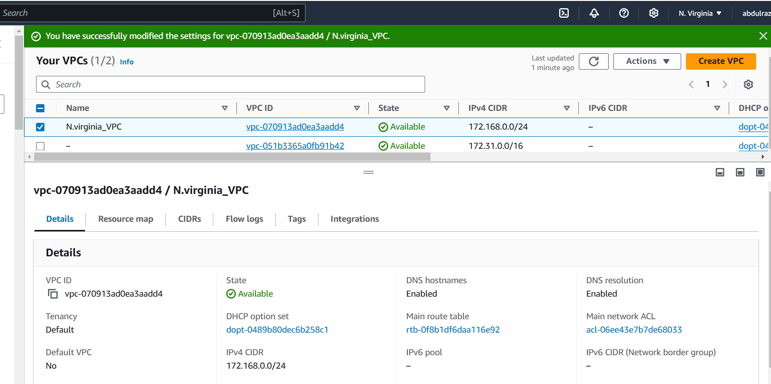

1. **Enable VPC peering for cross region.**

*-Connected to the ohio region ec2 by using its public IP:*

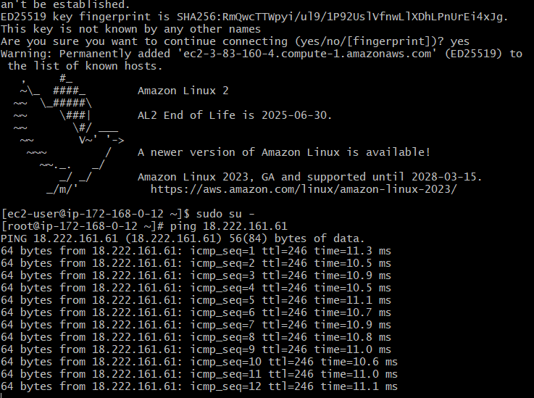

**-peering-virginia-ohio has been requested.**

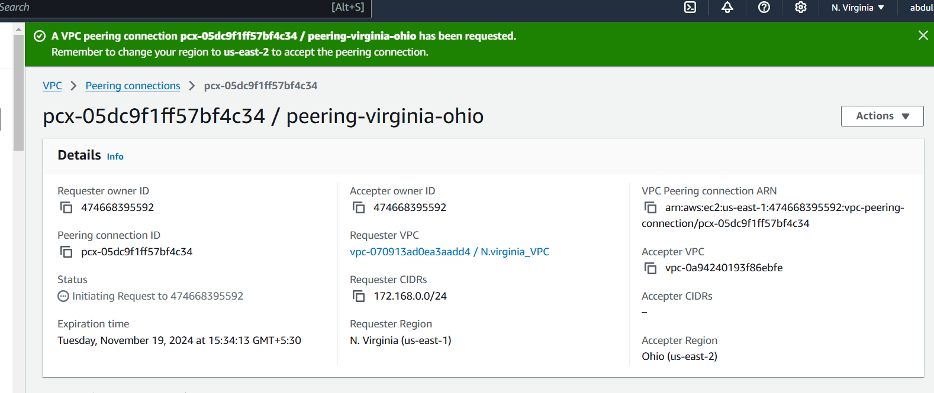

-Peering request accepted by ohio region VPC.

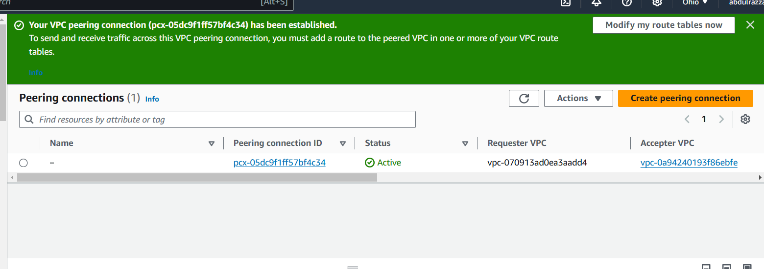

-Successfully established the connection from VPC (N.Virginia) to VPC (Ohio):

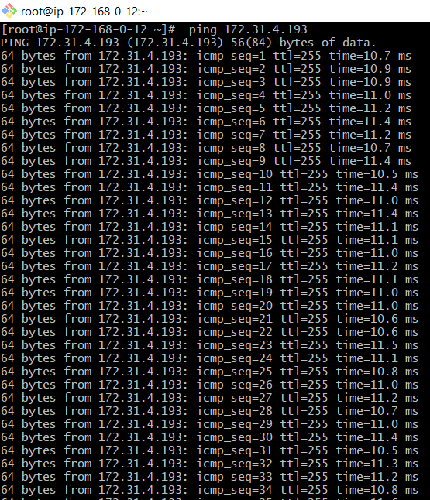

**3)Enable VPC peering for cross account. (You can collaborate with your friend and do this task).**

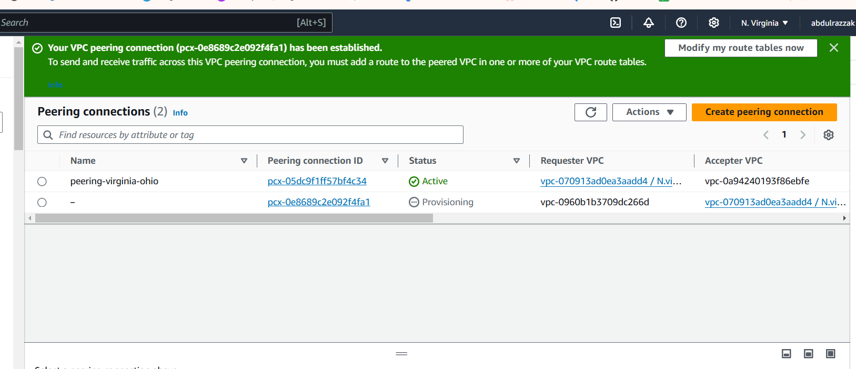

* *Connected to another account through VPC Peering:*

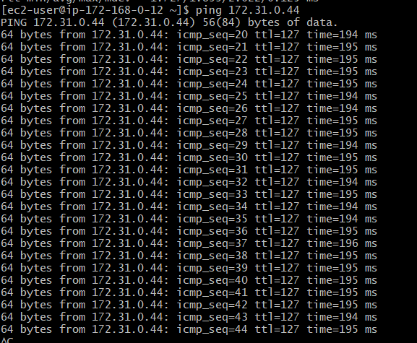

1. **Setup VPC Transist gateway.**

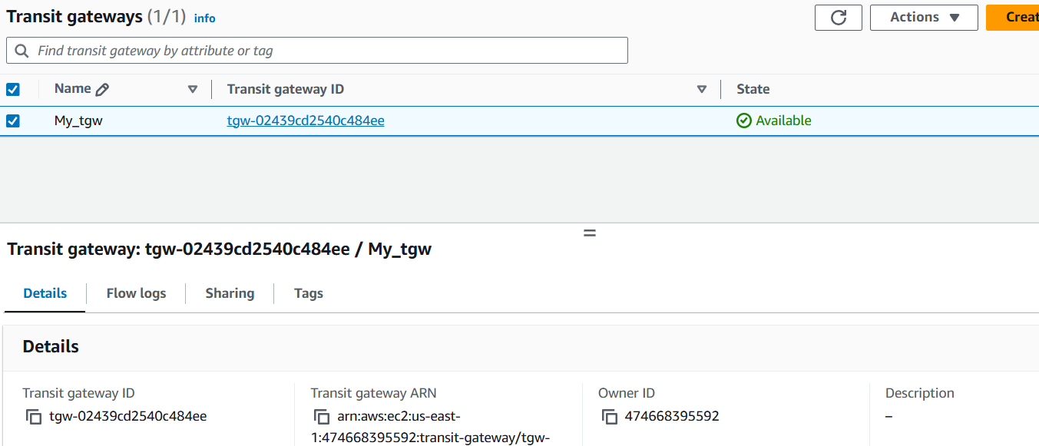

**4) Setup VPC Transist gateway.**

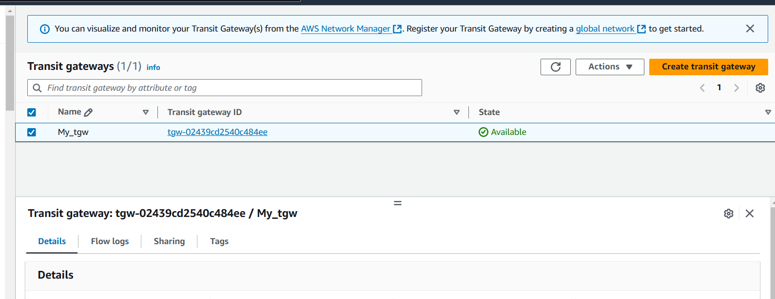

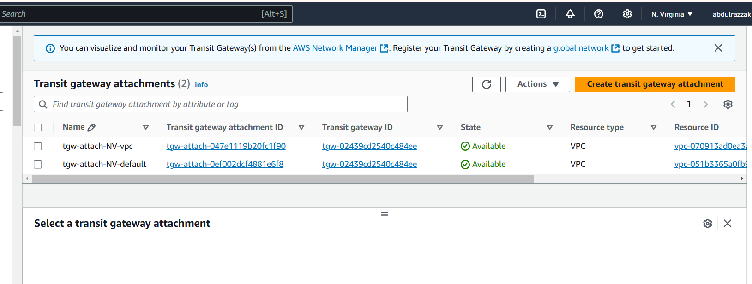

1. **Setup VPC End Point.**

